WEEK 9

Name of School: ……………………………………………………..……………………………….……..
Name of Teacher: ………………………..…………………………………………………………………
Date: |  | Day: MONDAY |  | Strand: MY LOCAL COMMUNITY
 |  |  |  | Sub Strand: Knowing Who The Important People/ Occupation In The Community
Class: KG 1 |  | Class Size:
Content Standard:  K1.4.2.1 Demonstrate knowledge of the people in the community and their occupation. |  |  | Indicator:  K1.4.2.1.1 Talk about who the neighbors are, the work they do and how important their profession are in the community  K1.4.2.1.7 Demonstrate their understanding of the concept of subtraction as separating and finding out how many is left
Performance Indicator:  - Learners to talk about who the neighbors are, the work they do and how important their profession are in the community.  - Learners can demonstrate their understanding of the concept of subtraction as separating and finding out how many is left |  |  |  |  | Core Competencies:  Communication and collaboration, Critical thinking, Personal Development and Leadership
Keywords:
Reference : KG Curriculum P.g. 17-20
Phase/Duration | Learners Activities |  |  |  |  | Resources
PHASE 1: STARTER | Let learners sing a song in relation to the lesson.  RCA QUESTION  1. Did you enjoy the song?  2. What words did you hear in the song?
PHASE 2: NEW LEARNING  CIRCLE TIME | Engage learners in the community circle time.  Lead learners to the play the ‘telephone’ game.  Come up with a simple sentence or ask one of your players to do so and write it down.  Whisper the words into the ear of the first learner and tell them to share it with the next one until it gets to the last child who gets to say the usually utterly different sentence out loud.  You can use this activity to explore the alphabet by dedicating each round to a different letter,  e.g. Angry Anna Ate Apples |  |  |  |  | Pot of honey
GROUP ACTIVITY 1  (OUTDOOR) | Give learners the opportunity to talk freely with the teacher and their peers about the people in their neighborhood and the work they do.  Learners should first talk about the occupation of their parents. e.g. My parents are both farmers.  Ask leading questions and job terminologies to guide the discussion on the theme (teacher, nurse, doctor, police officer, trader, fisherman, fishmonger, etc.).  Play some songs and let learners sing it along with the tape.  Talk about each profession and how important they are to the community.  Learners select the work they want to do when they grow up and draw themselves their uniform.  Sort the occupations into sets of formal and informal. Match the sets with their correct number.  Assign each corner of the class with numbers or popular characters in a story.  Share numbers to learners and let everyone stand in their respective corner.  Stand in the middle of the class with a giant dice.  The teacher rolls the dice, and the number that shows up is the corner to be out.  If he rolled a five, all will sing and dance to a familiar rhyme.  If he rolled a six, everyone out will get back to their respective corners.  The last corner to remain standing in its corner wins!  Assessment: Let learners role-play the profession they will take up in future. |  |  |  |  | Pictures and videos depicting important people and occupation in the community
PHONICS | Engage learners to sing songs and recite some familiar rhymes that relates to the target sound.  Guide learners to pronounce and write the target sound in the sand tray or exercise books.  Have learners say three or four words that contain the target sound.  Using flash cards, learners read words that contain the target sound.  RCA QUESTIONS  1. What sound have we learnt today?  2. Which other letter sound do you know?  3. Mention any object in the classroom or home that begins with the target letter sound. |  |  |  |  | Word cards, letter cards.
GROUP ACTIVITY 2  (INDOOR) | Review the concept of addition and concentrate on Subtraction this week.  Create a market scene where learners buy and sell different items in the community and use their understanding of the subtraction concept to buy with money and ask for a change.  The buyer asks the seller a question “how much is left”.  Create different everyday situations and scaffold learners to subtract numbers.  Let learners work in pairs and individually to solve problems in their exercise books.  It’s Bowling time.  Arrange or line up empty water bottles on the floor of the classroom.  Get learners to roll a ball as best as they can towards the bottles.  Have learners count the number of bottles they knocked down and write it in the air or board.  The person who knocks down the higher number wins, and the game continues.  Fill balloons with water and write a bunch of different addition equations on the balloons.  With sidewalk chalk, write the answer to the problems you created. For example, if you wrote 3+1 on a balloon, you’d create a circle with the number 4 in it.  Put learners into groups and let them read the problem on each balloon and throw the balloon at the circle they believe is the solution to the math problem
LEARNING CENTER | Engage learners to play freely at the learning centers.  Join in and ask learners questions frequently to guide their play. |  |  |  |  | Learning center
STORY SHARING | Tell learners a story.  Pause regularly and ask questions to make sure learners are following.  RCA QUESTION  1. Was the story interesting?  2. Which part of the story did you like?  3. what have you learnt from the story? |  |  |  |  | Word cards, letter cards.
PHASE 3: REFLECTION | Learners share what they have learnt with their peers.  Give learners homework to do at home

Date: |  | Day: TUESDAY |  |  | Strand: MY LOCAL COMMUNITY
 |  |  |  |  | Sub Strand: Knowing Who The Important People/ Occupation In The Community
Class: KG 1 |  |  | Class Size:
Content Standard:  K1.4.2.1 Demonstrate knowledge of the people in the community and their occupation. |  |  |  | Indicator:  K1.4.2.1.2 Demonstrate that sentences are made of words and that words are separated in print.  K1.4.2.1.4 Recognize the letter-sound learnt in the previous week in words
Performance Indicator:  - Learners can demonstrate that sentences are made of words and that words are separated in print.  - Learners can recognize the letter-sound learnt in the previous week in words. |  |  |  |  | Core Competencies:  Communication and collaboration, Critical thinking, Personal Development and Leadership
Keywords:
Reference : KG Curriculum P.g. 17-20
Phase/Duration | Learners Activities |  |  |  |  | Resources
PHASE 1: STARTER | Let learners sing a song in relation to the lesson.  RCA QUESTION  1. Did you enjoy the song?  2. What words did you hear in the song?
PHASE 2: NEW LEARNING  CIRCLE TIME | Engage learners in the community circle time.  Lead learners to play the ‘color hunt’ game.  Design and make your own simple color spinner.  Let each child in the circle spin the arrow and find something in the room that matches the color it shows.  Make it a rule that the items should not be repeated so that the little players focus when others take their turns. |  |  |  |  | flashcards
GROUP ACTIVITY 1  (OUTDOOR) | Use the “Be the word” game to demonstrate the concept.  Cut up a sentence into individual words.  Call a group of learners to rearrange the words to form the sentence.  Each child picks a word and be that word when the sentence is being rebuild.  Call learners to rearrange the words to form the sentence.  Make sure learners leave a space in between them when rearranging the words to form the sentence.  Scaffold them to see how words are separated in print.  Place ‘puddles’ on the floor and let children take turns jumping to each one. This can be done by having kids go one at a time, with the teacher calling out which puddle to jump to.  Alternatively, have a few children go at a time, calling out the puddle they will jump onto.  The puddles can be made using blue construction paper –then write a word, number, or letter on each  Engage learners to sing rhymes with actions and dance to it.  Example: FIVE IN THE BED  There were 5 in the bed  And the little one said, “roll over, roll over.”  So they all rolled over and one fell out  There were 4 in the bed  And the little one said, “roll over, roll over.”  (count down to 1)  There was one in the bed  And the little one said, I’ve got the whole bed to myself.  I’ve got the whole bed to myself.  I’ve got the whole bed to myself.  I’ve got the whole bed to myself.  Assessment: In groups, engage learners to do a treasure hunt for words beginning with the target letter in the classroom.  The group that finds more words with the target letter wins the game. |  |  |  |  | Big book, word card and sentence card, pictures and videos
PHONICS | Engage learners to sing songs and recite some familiar rhymes that relates to the target sound.  Guide learners to pronounce and write the target sound in the sand tray or exercise books.  Have learners say three or four words that contain the target sound.  Using flash cards, learners read words that contain the target sound.  RCA QUESTIONS  1. What sound have we learnt today?  2. Which other letter sound do you know?  3. Mention any object in the classroom or home that begins with the target letter sound. |  |  |  |  | Word cards, letter cards.
GROUP ACTIVITY 2  (INDOOR) | Show word cards out to students, have learners identify the letter sound /K/ [k] in the list of words. [Kwasi (Yes) mama (no), Kofi] etc.  Learners put their hands on the head when there is the target letter-sound in the word, if not they put their hands down.  Copy selected words on the board for learners write into their exercise books.  It’s Bowling time.  Arrange or line up empty water bottles on the floor of the classroom.  Get learners to roll a ball as best as they can towards the bottles.  Have learners count the number of bottles they knocked down and write it in the air or board.  The person who knocks down the higher number wins, and the game continues. |  |  |  |  | Big book, word card and sentence card, pictures and videos
LEARNING CENTER | Engage learners to play freely at the learning centers.  Join in and ask learners questions frequently to guide their play. |  |  |  |  | Learning center
STORY SHARING | Tell learners a story.  Pause regularly and ask questions to make sure learners are following.  RCA QUESTION  1. Was the story interesting?  2. What part of the story did you like?  2. Retell the story to your partner.  4. what have you learnt from the story? |  |  |  |  | Word cards, letter cards.
PHASE 3: REFLECTION | Learners share what they have learnt with their peers.  Give learners homework to do at home

Date: |  | Day: WEDNESDAY |  |  | Strand: MY LOCAL COMMUNITY
 |  |  |  |  | Sub Strand: Knowing Who The Important People/ Occupation In The Community
Class: KG 1 |  |  | Class Size:
Content Standard:  K1.4.2.1 Demonstrate knowledge of the people in the community and their occupation. |  |  |  | Indicator:  K1.4.2.1.5 Write boldly and legibly the target letter for the week and add a name of a friend to it  K1.4.2.1.7 Demonstrate their understanding of the concept of subtraction as separating and finding out how many is left
Performance Indicator:  - Learners can write boldly and legibly the target letter for the week and add a name of a friend to it.  - Learners can demonstrate their understanding of the concept of subtraction as separating and finding out how many is left. |  |  |  |  | Core Competencies:  Communication and collaboration (CC) Personal Development and Leadership (PL) Creativity and Innovation (CI) Critical Thinking and Problem Solving
Keywords:
Reference : KG Curriculum P.g. 17-20
Phase/Duration | Learners Activities |  |  |  |  | Resources
PHASE 1: STARTER | Let learners sing a song in relation to the lesson.  RCA QUESTION  1. Did you enjoy the song?  2. What words did you hear in the song?
PHASE 2: NEW LEARNING  CIRCLE TIME | Engage learners in the community circle time.  Lead learners to play the ‘hot potato’ game  Players arrange themselves in a circle and toss a small, round object (a tennis ball, an orange, or even a real potato will suffice) to each other while music plays.  The player who is holding the “hot potato” when the music stops is out.  The game continues until one player is left — that player is the winner |  |  |  |  | Clothes, pins
GROUP ACTIVITY 1  (OUTDOOR) | Have learners practice exercising the fingers. Refer to the previous writing lesson, and have learners practice in the air, on the other surfaces and on paper.  Have learners give examples of words that contain the letter of the week.  Have learners form sentences with the selected words and count the words in their sentences.  Learners in pairs sum up the number of words in their sentences.  Get about ten to twenty colored balloons. Put learners into two color groups, say red and yellow.  Now put up a big empty box at one part of the classroom as learners stands far apart facing the box.  Choose one child from the color group to participate in the race.  At the word ‘go’, they must throw the balloons (ten each) into the box facing them. The first person to finish wins.  The game continues as long as the children are having fun. |  |  |  |  | Posters and pictures  Pencils, crayons etc.  Number cards, counters, model numbers etc.  Cut-out shapes  Play toys, skipping rope, tyres etc
PHONICS | Engage learners to sing songs and recite some familiar rhymes that relates to the target sound.  Guide learners to pronounce and write the target sound in the sand tray or exercise books.  Have learners say three or four words that contain the target sound.  Using flash cards, learners read words that contain the target sound.  RCA QUESTIONS  1. What sound have we learnt today?  2. Which other letter sound do you know?  3. Mention any object in the classroom or home that begins with the target letter sound. |  |  |  |  | Word cards, letter cards.
GROUP ACTIVITY 2  (INDOOR) | Create different everyday situations and scaffold learners to subtract numbers by crossing out.  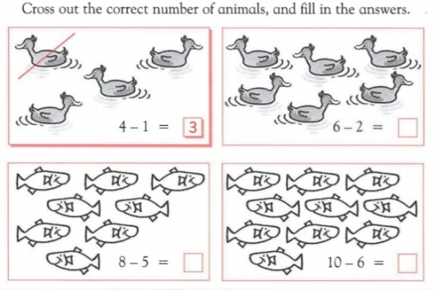  Let learners work in pairs and individually to solve problems in their exercise books.  Teach, sing songs and recite rhymes in relation to the lesson.  Learners to sing the songs, recite rhymes and dance with actions.  Make a choice to use any of the learning centers created  Listen to a story  Assessment: Have learners solve the following in their workbooks.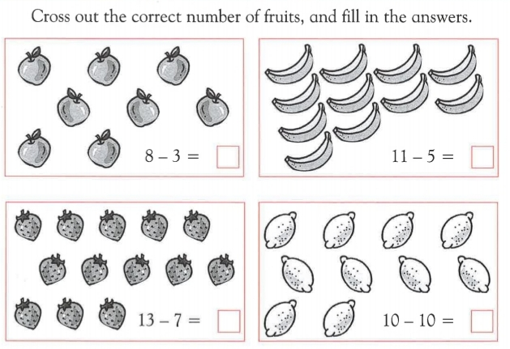 |  |  |  |  | Posters and pictures  Pencils, crayons etc.  Number cards, counters, model numbers etc.  Cut-out shapes  Play toys, skipping rope, tyres etc
LEARNING CENTER | Engage learners to play freely at the learning centers.  Join in and ask learners questions frequently to guide their play. |  |  |  |  | Learning center
STORY SHARING | Tell learners a story.  Pause regularly and ask questions to make sure learners are following.  RCA QUESTION  1. Was the story interesting?  2. What part of the story did you like?  2. Retell the story to your partner.  4. what have you learnt from the story? |  |  |  |  | Word cards, letter cards.
PHASE 3: REFLECTION | Learners share what they have learnt with their peers.  Give learners homework to do at home

Date: |  | Day: THURSDAY |  |  | Strand: MY LOCAL COMMUNITY
 |  |  |  |  | Sub Strand: Knowing Who The Important People/ Occupation In The Community
Class: KG 1 |  |  | Class Size:
Content Standard:  K1.4.2.1 Demonstrate knowledge of the people in the community and their occupation. |  |  |  | Indicator:  K1.4.2.1.1 Talk about who the neighbors are, the work they do and how important their profession are in the community  K1. 4.2.1.6. Draw themselves in the uniform of their aspired future job, color it nicely and write the name of the job underneath
Performance Indicator:  - Learners can talk about who the neighbors are, the work they do and how important their profession are in the community.  - Learners can draw themselves in the uniform of their aspired future job, color it nicely and write the name of the job underneath. |  |  |  |  | Core Competencies:  Communication and collaboration, Critical thinking, Personal Development and Leadership
Keywords:
Reference : KG Curriculum P.g. 17-20
Phase/Duration | Learners Activities |  |  |  |  | Resources
PHASE 1: STARTER | Let learners sing a song in relation to the lesson.  RCA QUESTION  1. Did you enjoy the song?  2. What words did you hear in the song?
PHASE 2: NEW LEARNING  CIRCLE TIME | Engage learners in the community circle time.  Mark ‘North’, ‘South’, ‘East’ and ‘West’ on the four walls of your class. Get your circle time group to pretend they are in a boat in the middle of the class.  Shout out a direction to get the group to move towards that direction and back to the middle.  If the command is to sail ‘all around the world’, the group will have to move to touch all four walls and get back to the middle. |  |  |  |  | Flashcards
GROUP ACTIVITY 1  (OUTDOOR) | Learners to talk freely about the other people in their neighborhood and the work they do.  e.g. i. Mr. Obeng is Doctor, he works at the hospital.  ii. Mrs. Esther Antwi is a banker, she works at the Ghana Commercial Bank.  Ask leading questions and job terminologies to guide the discussion on the theme (teacher, nurse, doctor, police officer, trader, fisherman, fishmonger, etc.).  Teach learners rhymes about work and let them sing and dance with actions. E.g.  WORK AND PLAY  Work while you work ,  Play while you play,  That is the way,  To be happy and gay.  All that you do,  Do with all your might,  Things done by halves,  Are never done right.  Talk about each profession and how important they are to the community.  Assign each corner of the class with numbers or popular characters in a story.  Share numbers to learners and let everyone stand in their respective corner.  Stand in the middle of the class with a giant dice.  The teacher rolls the dice, and the number that shows up is the corner to be out.  If he rolled a five, all will sing and dance to a familiar rhyme.  If he rolled a six, everyone out will get back to their respective corners.  The last corner to remain standing in its corner wins!  Get about ten to twenty colored balloons. Put learners into two color groups, say red and yellow.  Now put up a big empty box at one part of the classroom as learners stands far apart facing the box.  Choose one child from the color group to participate in the race.  At the word ‘go’, they must throw the balloons (ten each) into the box facing them. The first person to finish wins.  The game continues as long as the children are having fun |  |  |  |  | Poster/ cut out pictures, Cut out shapes, big books, counters, crayons, word cards and number cards
PHONICS | Engage learners to sing songs and recite some familiar rhymes that relates to the target sound.  Guide learners to pronounce and write the target sound in the sand tray or exercise books.  Have learners say three or four words that contain the target sound.  Using flash cards, learners read words that contain the target sound.  RCA QUESTIONS  1. What sound have we learnt today?  2. Which other letter sound do you know?  3. Mention any object in the classroom or home that begins with the target letter sound. |  |  |  |  | Word cards, letter cards.
GROUP ACTIVITY 2  (INDOOR) | Learners select the work they want to do when they grow up and draw themselves their uniform.  Show poster and/or pictures depicting professionals in informs.  Learners choose their future jobs and talk to each other about why they made that selection.  Have learners be in groups according to their chosen profession and count the members in each group.  Assessment: Have choose their future jobs, draw and color themselves and paste it all round the classroom |  |  |  |  | Posters and pictures  Pencils, crayons etc.  Number cards, counters, model numbers etc.  Cut-out shapes  Play toys, skipping rope, tyres etc
LEARNING CENTER | Engage learners to play freely at the learning centers.  Join in and ask learners questions frequently to guide their play. |  |  |  |  | Learning center
STORY SHARING | Tell learners a story.  Pause regularly and ask questions to make sure learners are following.  RCA QUESTION  1. Was the story interesting?  2. What part of the story did you like?  2. Retell the story to your partner.  4. what have you learnt from the story? |  |  |  |  | Word cards, letter cards.
PHASE 3: REFLECTION | Learners share what they have learnt with their peers.  Give learners homework to do at home

Date: |  | Day: FRIDAY |  |  | Strand: MY LOCAL COMMUNITY
 |  |  |  |  | Sub Strand: Knowing Who The Important People/ Occupation In The Community
Class: KG 1 |  |  | Class Size:
Content Standard:  K1.4.2.1 Demonstrate knowledge of the people in the community and their occupation. |  |  |  | Indicator:  K1.4.2.1.5 Write boldly and legibly the target letter for the week and add a name of a friend to it  K1.4.2.1.7 Demonstrate their understanding of the concept of subtraction as separating and finding out how many is left
Performance Indicator:  - Learners can write boldly and legibly the target letter for the week and add a name of a friend to it.  - Learners to demonstrate their understanding of the concept of subtraction as separating and finding out how many is left. |  |  |  |  | Core Competencies:  Communication and collaboration, Critical thinking, Personal Development and Leadership
Keywords:
Reference : KG Curriculum P.g. 17-20
Phase/Duration | Learners Activities |  |  |  |  | Resources
PHASE 1: STARTER | Let learners sing a song in relation to the lesson.  RCA QUESTION  1. Did you enjoy the song?  2. What words did you hear in the song?
PHASE 2: NEW LEARNING  CIRCLE TIME | Engage learners in the community circle time.  Stir in some fun into circle time with the alphabet soup game.  Get your group to join in for some pretend play and make a pot of alphabet soup with some magnetic alphabets.  Bring in a pot and ladle and chuck in the alphabets. Tell the group to put on their pretend chef-hats.  Invite each child to come over to the pot, give it a good stir and scoop out an alphabet. When a child finds an alphabet, get them to show it to the group and let them identify the alphabet. |  |  |  |  | Bowl, water, alphabets.
GROUP ACTIVITY 1  (OUTDOOR) | Create different everyday situations and scaffold learners to subtract numbers by crossing out.  Cross out one type of shape in each box.  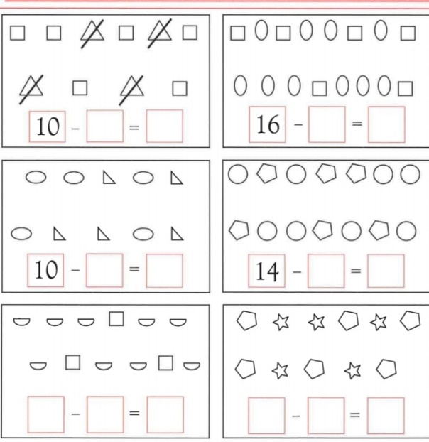  Let learners work in pairs and individually to solve problems in their exercise books.  Assign each corner of the class with numbers or popular characters in a story.  Share numbers to learners and let everyone stand in their respective corner.  Stand in the middle of the class with a giant dice.  The teacher rolls the dice, and the number that shows up is the corner to be out.  If he rolled a five, all will sing and dance to a familiar rhyme.  If he rolled a six, everyone out will get back to their respective corners.  The last corner to remain standing in its corner wins!  Get about ten to twenty colored balloons. Put learners into two color groups, say red and yellow.  Now put up a big empty box at one part of the classroom as learners stands far apart facing the box.  Choose one child from the color group to participate in the race.  At the word ‘go’, they must throw the balloons (ten each) into the box facing them. The first person to finish wins.  The game continues as long as the children are having fun.  Assessment: Give the learners a sentence orally. They must tell you the number of words in the sentence. Make it harder by using words with more than one syllable e.g. The teacher rides her bicycle. You can help the children to check the answer by writing the sentence on the board. |  |  |  |  | Poster/ cut out pictures, Cut out shapes, big books, counters, crayons, word cards and number cards
PHONICS | Engage learners to sing songs and recite some familiar rhymes that relates to the target sound.  Guide learners to pronounce and write the target sound in the sand tray or exercise books.  Have learners say three or four words that contain the target sound.  Using flash cards, learners read words that contain the target sound.  RCA QUESTIONS  1. What sound have we learnt today?  2. Which other letter sound do you know?  3. Mention any object in the classroom or home that begins with the target letter sound. |  |  |  |  | Word cards, letter cards.
GROUP ACTIVITY 2  (INDOOR) | Take learners through the creeping activities for them to exercise their wrists.  Learners to crawl under chairs, through a tunnel or on the field.  Have learners give examples of words that contain the letter of the week.  Have learners form sentences with the selected words and count the words in their sentences.  Learners in pairs sum up the number of words in their sentences.  It’s Bowling time.  Arrange or line up empty water bottles on the floor of the classroom.  Get learners to roll a ball as best as they can towards the bottles.  Have learners count the number of bottles they knocked down and write it in the air or board.  The person who knocks down the higher number wins, and the game continues.  Fill balloons with water and write a bunch of different addition equations on the balloons.  With sidewalk chalk, write the answer to the problems you created. For example, if you wrote 3+1 on a balloon, you’d create a circle with the number 4 in it.  Put learners into groups and let them read the problem on each balloon and throw the balloon at the circle they believe is the solution to the math problem. |  |  |  |  | Posters and pictures  Pencils, crayons etc.  Number cards, counters, model numbers etc.  Cut-out shapes  Play toys, skipping rope, tyres etc
LEARNING CENTER | Engage learners to play freely at the learning centers.  Join in and ask learners questions frequently to guide their play. |  |  |  |  | Learning center
STORY SHARING | Tell learners a story.  Pause regularly and ask questions to make sure learners are following.  RCA QUESTION  1. Was the story interesting?  2. What part of the story did you like?  2. Retell the story to your partner.  4. What have you learnt from the story? |  |  |  |  | Word cards, letter cards.
PHASE 3: REFLECTION | Learners share what they have learnt with their peers.  Give learners homework to do at home.

Vetted by: ………………………………….…. Sign: …………………… Date: ………………..……..

